PROJECT REPORT
Summer Training – Power BI

Project Title | Climate Change Effects on Global Health
Student Name | Arshveer Singh
Roll Number | 2405043242
Course & Batch | B.Tech (2024-2028)
Department | Blockchain
Institute | CGC University, Mohali
Training Period | 8/6/2026 to 6/7/2026
Submission Date | 3 July 2026
Guided By | Dr. Ashima, Ms. Mandeep Kaur

1. Declaration
I hereby declare that the project report entitled “Climate Change Effects on Global Health” submitted in partial fulfilment of the Summer Training Programme is an original piece of work carried out by me. The data used in this report has been collected from publicly available sources. The dashboards and visuals shown in this report have been independently created by me in Microsoft Power BI Desktop.
I further confirm that this report or any part of it has not been submitted previously for any academic award.
Signature: ______________________________
Name: Arshveer Singh
Date: 03 / 07 / 2026

2. Abstract
This project examines how climate change and related environmental anomalies affect global human health, using a public dataset of 14,100 records across 30 columns covering the period 2015 to 2025. The dashboard is aimed at health boards, hospitals, climate researchers, and elder-care planners who need a clearer view of how temperature anomalies, air quality, and food security connect to disease trends. The dataset was checked and cleaned using Python (NumPy and Pandas), after which Excel pivot tables and visuals were used to explore relationships between columns, and DAX measures were created to support the Power BI dashboard. The final dashboard brings together KPI cards, trend lines, a disease-type breakdown, and country-level maps to make these patterns easy to read at a glance. Key outcomes include a steady rise in global temperature anomalies since 2015, a sharp increase in heat-related hospital admissions in 2025, and a clear link between income level and healthcare access high-income countries average around 85 in healthcare access compared with roughly 45 in lower-middle-income countries. The dashboard also highlights respiratory diseases as the most common climate-linked health issue and shows cardio-mortality rising alongside PM2.5 levels in 2023.

3. Introduction

3.1 Background
Climate change driven by industrial development, global warming, and related environmental shifts is altering atmospheric conditions in ways that go beyond weather. These changes are increasingly linked to measurable impacts on human health, from heat-related admissions to shifts in vector-borne and respiratory disease patterns. In the public-health and climate-research domain, dashboards are valuable because they let analysts and decision-makers move from scattered raw statistics to a single, interactive view of how environmental indicators (temperature, air quality, food security) move together with health outcomes across countries and income groups.

3.2 Problem Statement
The changes in climate caused by development, global warming, and related factors affect the atmosphere in many different ways, producing anomalies that in turn cause various diseases and health issues for people. Health boards, hospitals, elder-care services, and climate researchers currently lack an easy, unified way to see how these environmental anomalies translate into health risk across different countries and income levels. This project builds an interactive dashboard so that these target users can quickly identify which regions and populations are most at risk, and which environmental factors are driving the biggest health impacts, making it easier to prioritise interventions and further research.

3.3 Objectives
- Check that the dataset is clean using Python (NumPy, Pandas) and analyse it.
- Build Excel pivot tables and visuals to better understand relationships between columns.
- Create the DAX measures needed to understand the data more effectively.
- Design a dashboard with all the essential charts for understanding the dataset.
- Publish the final project.

4. Dataset Description

4.1 Data Source
Source Name | Kaggle
Dataset Name | Global Climate-Health Impact Tracker (2015-2025)
File Format | CSV
Number of Records | 14,100 rows
Number of Columns | 30 columns
Time Period Covered | 2015 – 2025
Download Link | https://www.kaggle.com/datasets/sohumgokhale/global-climate-health-impact-tracker-2015-2025

4.2 Key Fields / Columns
Column Name | Description / Role in Analysis
Country name | Used for representing countries
Year | Used for comparing the timeline
Healthcare access | How much access people had to healthcare in different countries
Income level | Categorises countries by the income level of their people
Food security | The security of food quality in the country
Temperature Anomalies | The increase in temperature relative to the average predicted

4.3 Data Quality Issues & Cleaning Steps
- Checked the dataset for cleanliness using Python (NumPy, Pandas) before analysis.
- Removed duplicate rows — no duplicates found and removed.
- Handled null values — Had no null values

5. Data Modelling

5.1 Model Diagram

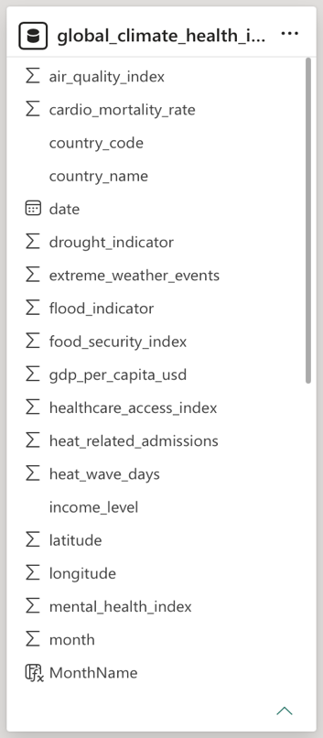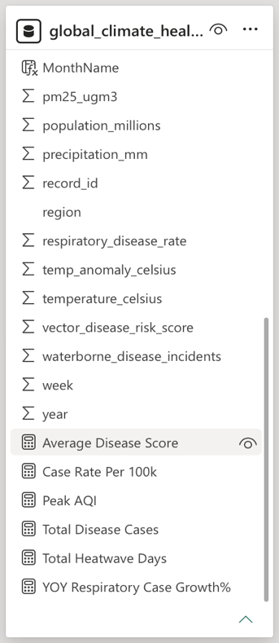

6. Dashboard & Visuals

6.1 Page 1 — Global Climate Change Effects Overview
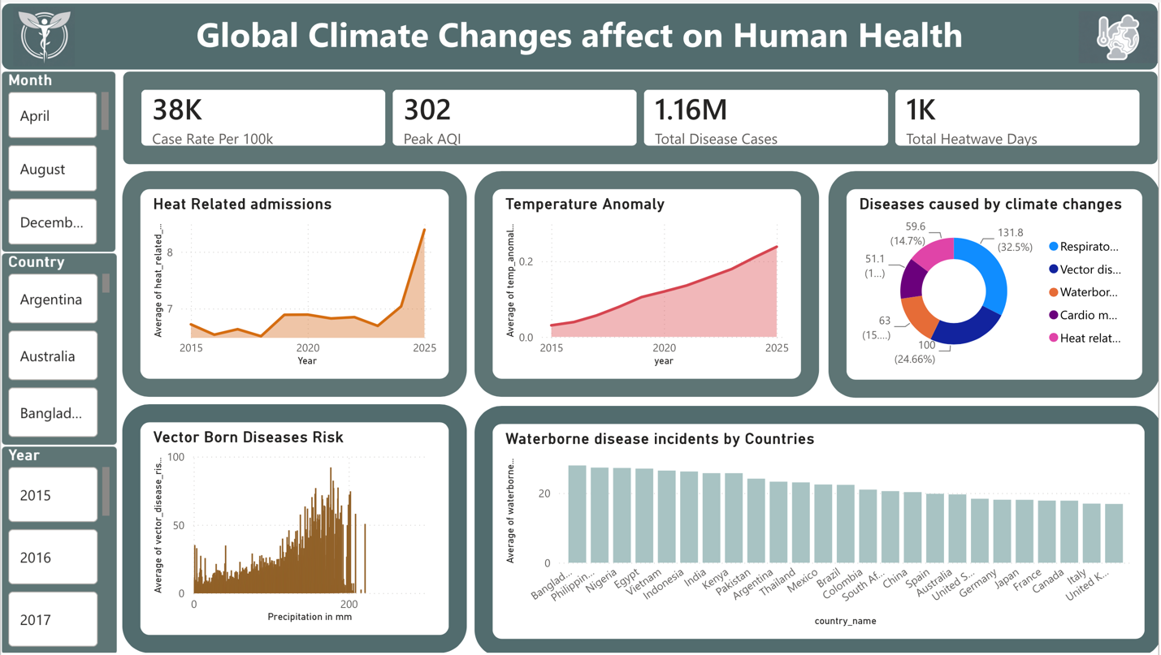
Visuals used on this page:
- KPI Cards — Case Rate per 100k (38K), Peak AQI (302), Total Disease Cases (1.16M), Total Heatwave Days (1K)
- Line Chart — Heat Related Admissions by Year
- Area Chart — Temperature Anomaly by Year
- Donut Chart — Diseases caused by climate change (Respiratory, Vector, Waterborne, Cardio, Heat-related)
- Histogram — Vector Born Diseases Risk vs. Precipitation
- Bar Chart — Waterborne disease incidents by Country
- Slicers — Month, Country, Year
Key insight from this page: Respiratory and vector-borne diseases account for the largest share of climate-linked disease cases, and heat-related admissions show a sharp spike in 2025 after remaining relatively flat from 2015–2023.

6.2 Page 2 — Health & Environmental Indicators
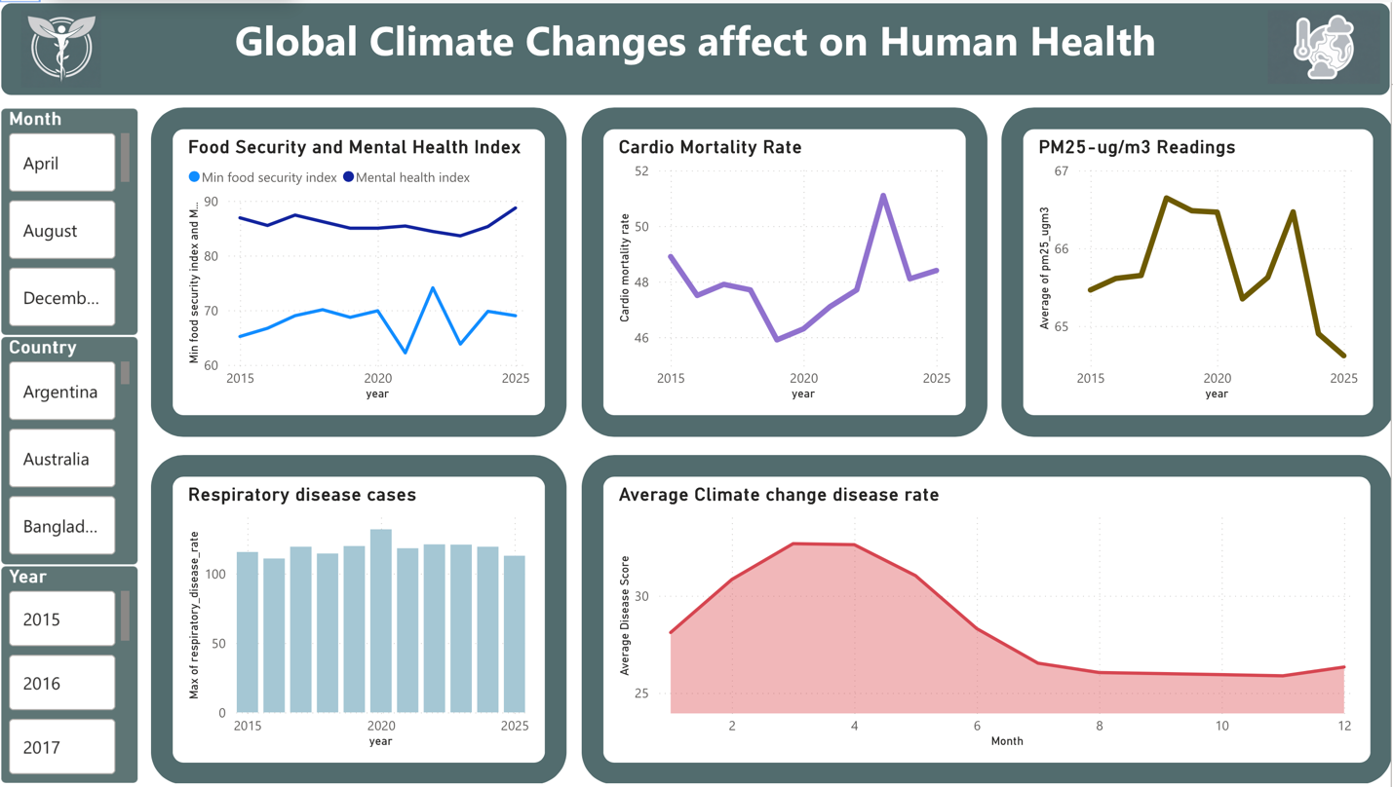
Visuals used:
- Line Chart — Food Security Index and Mental Health Index by Year
- Line Chart — Cardio Mortality Rate by Year
- Line Chart — PM2.5-ug/m3 Readings by Year
- Bar Chart — Respiratory Disease Cases by Year
- Area Chart — Average Climate Change Disease Rate by Month
Key insight from this page: Cardio mortality rate rises sharply alongside the 2023 peak in PM2.5 readings, while respiratory disease cases stay consistently high across all years, peaking around 2020.

6.3 Additional Analysis Pages

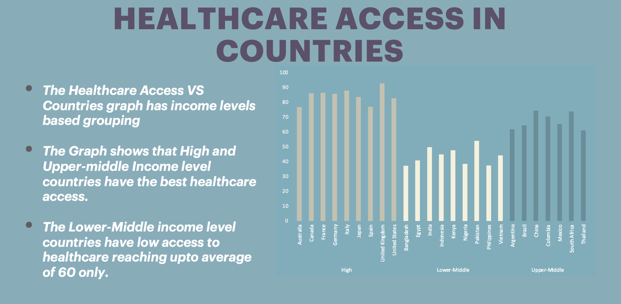

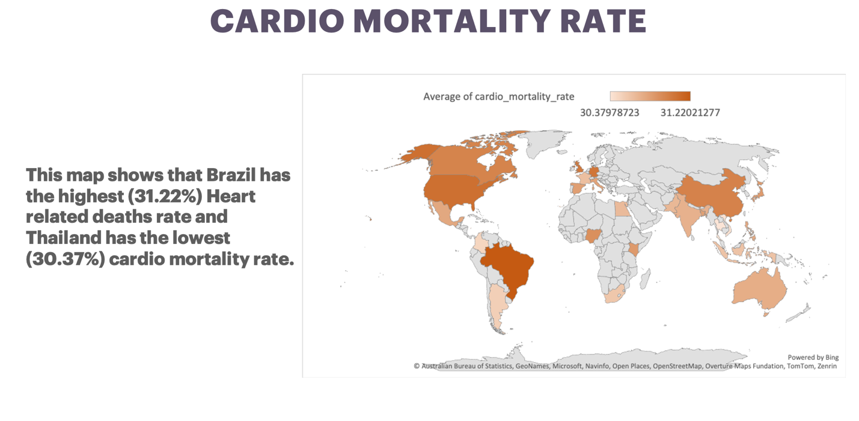

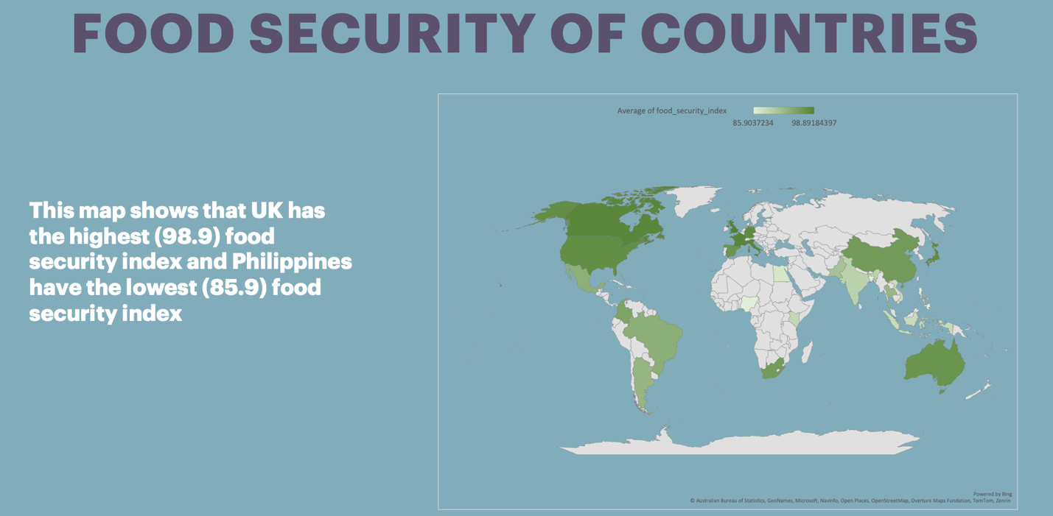
Filter/drill used: Country and Income Level
What these pages show: A healthcare-access comparison across countries grouped by income level (High, Upper-Middle, Lower-Middle), a world map of cardio mortality rate by country, and a world map of food security index by country.

7. Key Findings & Insights
- The data showed a steady increase in average global temperature from 2015 to 2025.
- Average PM2.5 (µg/m³) readings decreased slightly in 2025 (64.6) compared with 2015 (65.4).
- Healthcare access varies strongly with income level: high-income countries averaged 85 in healthcare access while lower-middle-income countries averaged only 45.
- Heat-related admissions increased massively in 2025 compared with 2015.
- Respiratory disease cases were the most common among all climate-linked disease categories.
- The highest AQI recorded globally between 2015 and 2025 was 302.
- Spring showed the sharpest rise in climate-change-related disease cases across the 2015–2025 decade.
- Vector-borne diseases increase sharply once precipitation crosses 110 mm.
- Cardio mortality showed a sudden spike alongside the rise in PM2.5 readings in 2023.
- Brazil recorded the highest cardio mortality rate (31.22%) while Thailand recorded the lowest (30.37%).
- The UK recorded the highest food security index (98.9) while the Philippines recorded the lowest (85.9).

8. Learnings

8.1 Skills Learned
- Cleaning and analysing a real-world dataset using Python (NumPy and Pandas).
- Building Excel pivot tables and visuals to explore relationships between columns.
- Writing DAX measures to support dashboard calculations.
- Designing an interactive, multi-page Power BI dashboard with KPI cards, trend charts, and country-level maps.

9. Conclusion
This project successfully analysed and visualised the effects of climate anomalies on global health and disease trends. The dashboard confirms that global temperature has increased steadily since 2015 and shows clearly that healthcare access in countries varies with their income level — High, Upper-Middle, and Lower-Middle. It gives health boards, hospitals, elder-care services, and climate researchers a single interactive view to identify which regions and populations face the greatest climate-linked health risks, supporting faster, more targeted decisions. Given more time, the project could be extended with predictive modelling of future disease trends and a more granular, city-level breakdown of environmental and health indicators. This training experience strengthened practical skills in Python-based data cleaning, Excel analysis, DAX, and Power BI dashboard design.

10. References
- Microsoft Power BI Documentation — https://docs.microsoft.com/en-us/power-bi
- Dataset Source — Kaggle — https://www.kaggle.com/datasets/sohumgokhale/global-climate-health-impact-tracker-2015-2025
- DAX Reference Guide — https://dax.guide
- Power Query M Reference — https://docs.microsoft.com/en-us/powerquery-m

END OF REPORT

